

**Nsu CPC:Find job in easily!**

Jubair Alam Ovi-1420145642

Date:26.05.21

**INTRODUCTION:**

NSU CPC is an app where students of North South University can easily find jobs of internship and this is the main idea of this app.There are many apps or platform like bdjobs ,kaj key etc but all those apps are for everyone and sometimes we can not find the right job for us .So NSU CPC will help all nsuers to find the right job for them .

**Features**

* Modern UI design
* Students registration and login .
* Firebase Authentication
* Job post
* Job Apply
* CPC admin
* Modern UI design

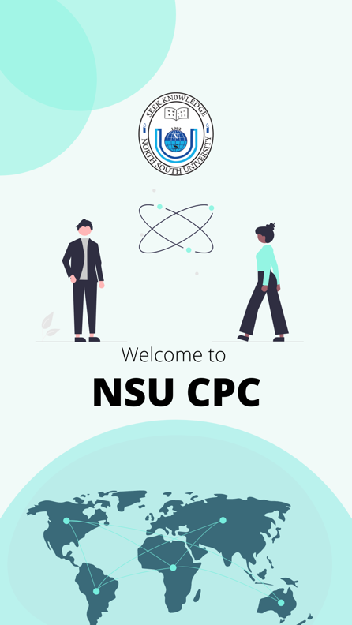 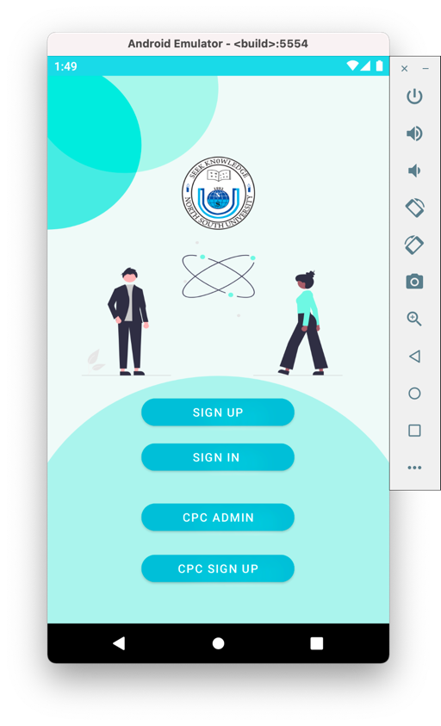

* Students registration and login .

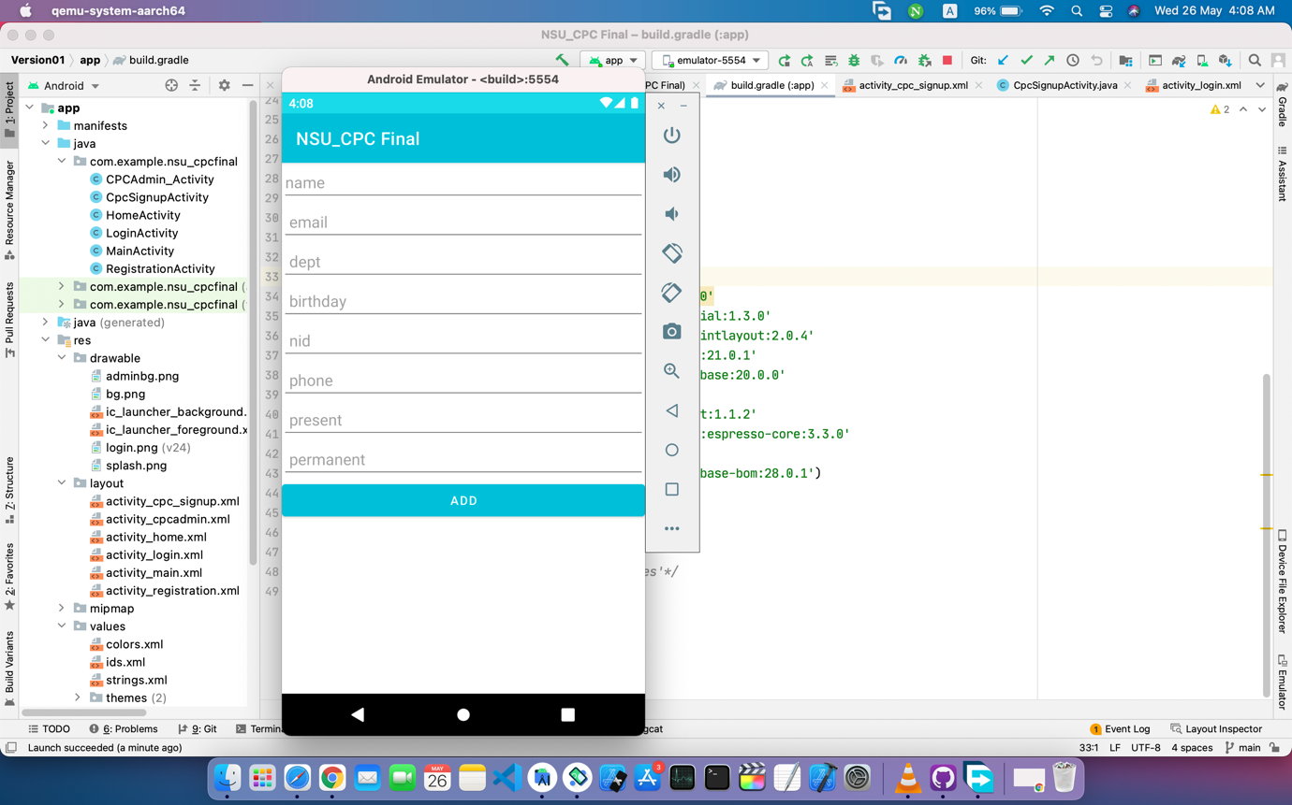

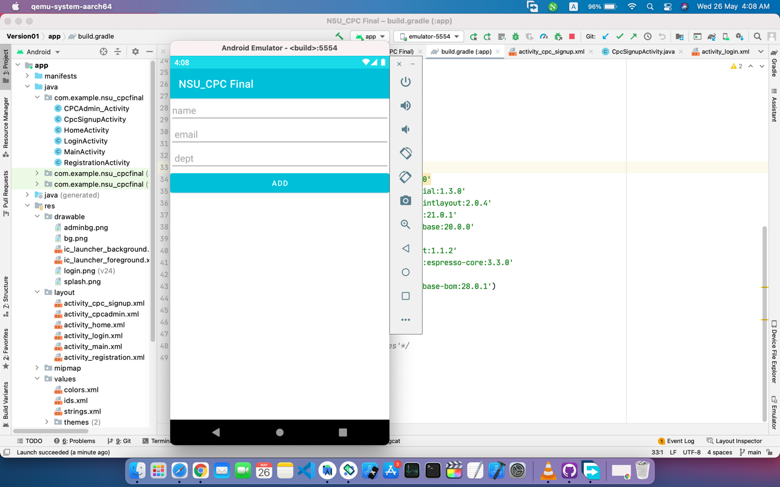

* CPC admin

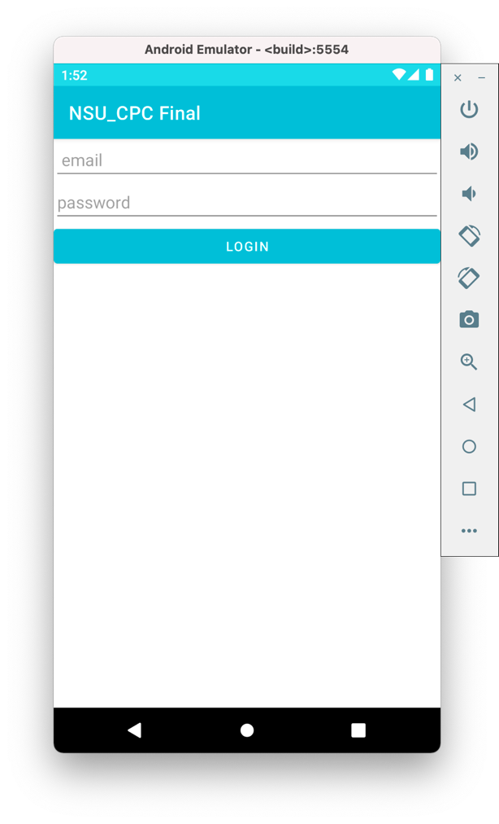 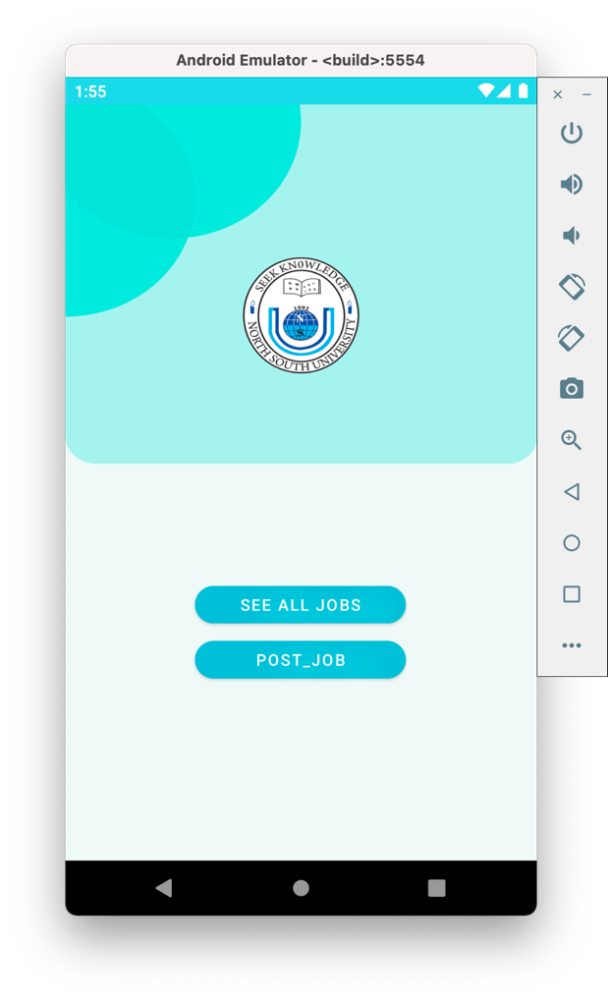

* Job post

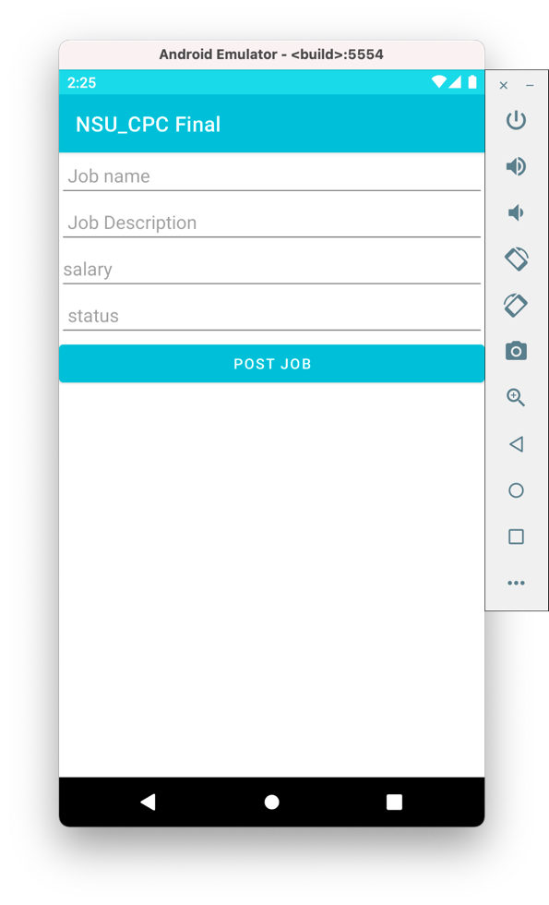

Database:

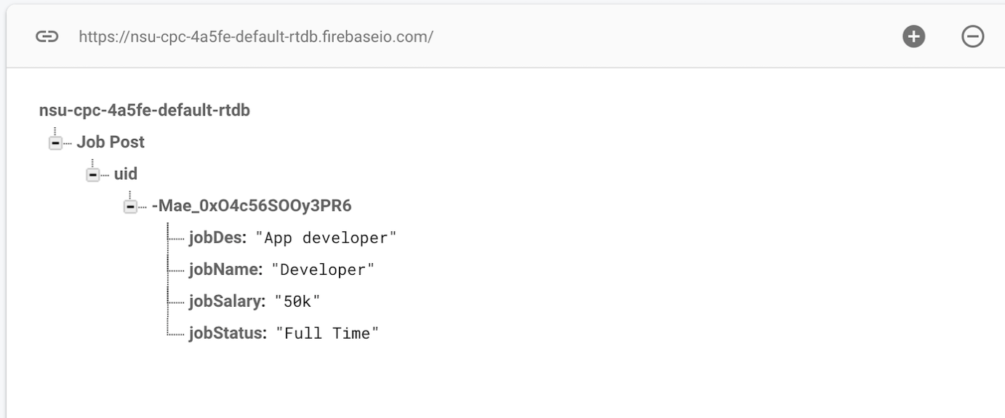

**Data Management:**

For data management I have used firebase .Firebase is much efficient for data storage and mining large-scale data .I have also done firebase authentication for login and Registration .

**Design Pattern:**

For design pattern I have followed my figma design prototype but due to the shortage of time work is not done yet .

**Future Work :**

Due to the shortage of time and some problems of Android Studio ,there are some works which need to be done in future .